July 3, 2025,

Dear and ,

Per today's phone call, thank you for considering the Law Offices of Reed, Jodrey, & Associates and Legacy Gurus, PLLC for your estate planning needs.
As discussed, here is a Summary of the Client Engagement and Estate Planning Process:
We will provide clients with firm introduction materials, including website resources and educational videos and webinars. We will then schedule an initial and/or second consultation (no charge) to begin assessment of the client's estate planning needs and determine appropriate legal services. Client engages the firm for legal services (Starter Estate Planning Package: $350.00, subject to additional written estate planning fee agreement depending on the estate plan chosen by client). Attorney Reed & staff shall also help the client get properly organized with an optional 5-year secure digital document storage system and medical information card (see website videos https://www.reedjodrey.com/ ) & we will begin to complete the “Family Wealth Planning Session" inventory assessment. We will then schedule an appointment with Legacy Gurus for the next estate planning consultation and to discuss Health Care Power of Attorney, Durable Financial Power of Attorney, HIPAA Authorization Forms, and any other estate planning documents.

Whatever plan you choose for estate planning services, an additional flat fee will then be paid (minus the $350 credit for the initial payment). All fees and the scope of services will be further detailed in that second written engagement agreement.
Schedule a document execution meeting to review and sign estate planning documents, with written confirmation of the next periodic review date.
Attorney Reed shall meet with client via video conference or in person.

Maintain ongoing client communication through approved channels, including newsletters, blog posts, webinars, and educational videos, subject to attorney advertising rules.

At this point in time, we only represent you, and no other people in connection with this engagement. The Rules of Professional Conduct, the governing body which oversees the activities of attorneys, and the Firm’s internal guidelines, recommends that attorneys establish the terms of the engagement at the outset of their work. Therefore, this letter is set forth to comply with the Rules of Professional Conduct recommendations and to provide the terms under which the Firm will provide legal services to you, the client.

Scope of Engagement; Flat Fee :

INITIAL CONSULTATIONFAMILY WEALTH PLANNING SESSION: You have agreed to pay $350.00 flat fee to the Law Offices of Reed, Jodrey, & Associates. This fee also covers the initial consultation known as a “Family Wealth Planning Session” with Amanda Wright, Legacy Gurus, to choose an estate planning package that works for you. We will set up this meeting by booking a call with the Legacy Gurus Legal Administrator, Rocio, here.
ESTATE- PLANNING FLAT FEE PAYMENT: During this “Family Wealth Planning Session” you may select the estate planning package that works for you. Most clients select from the following:
Family Plan (Will Plan);
Wealth Plan (Revocable Trust Plan); or
Legacy Plan (Irrevocable Trust Plan also known as Medicaid Asset protection).
Each plan serves a different purpose, and flat fees can range from $1,500 to $10,000, depending on your goals and objectives. Rest assured you will never be charged hourly, and you will select the plan that works for you, your family, or your loved ones.
Overview of Packages: We offer transparent, upfront, flat-fee pricing, and payment plans. Please see below for an overview of some of our packages. We will walk you through the differences and you will select your package and sign an Appendix to this agreement.

Law Offices of Reed, Jodrey, & Associates Discount will be applied to your final package choice: $___________
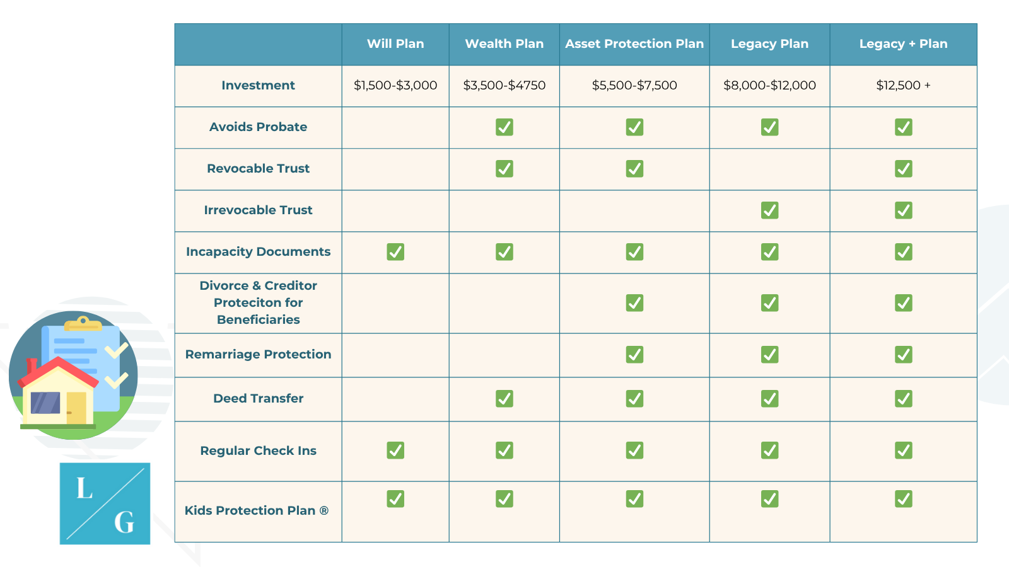

FUNDING YOUR TRUST/RETITLING (if applicable)
“Funding Your Trust” (also called “retitling”) - Your Trust is only effective to meet your goals to the extent it is “funded.” This means that you must retitle certain accounts, or update beneficiaries on accounts. Please note that our staff won't provide direct assistance with the funding process unless you choose the Legacy + Plan. For example, we can’t call your life insurance broker on your behalf or visit the bank on your behalf. These are things YOU will have to do after your plan is signed. However, this is an important part of your planning, and we remind you several times. You'll receive comprehensive and detailed instructions to help you transfer your assets into your trust, also called retitling.

Limitations on the Engagement:
- Our engagement and the services that we will render to you are limited strictly to those services outlined above It is understood that we are not providing, and you are not relying on us for, tax planning, business, investment, accounting, or valuation decisions, or to investigate the character or credit of persons or firms with whom you may be dealing (such as insurance companies or investment advisors). Our Firm advises clients to seek advice from a professionally licensed accountant, CPA, and/or investment Firm.
- Upon completion of this matter, changes may occur in pertinent laws or regulations that will have an impact upon your future rights and liabilities. Unless you engage us after completion of this matter to provide advice on issues arising from this matter, the Firm will have no obligations to provide any advice to you or to your clients with respect to future legal developments, with the exception of the statement above.
- Hourly Rates: We are required to disclose our hourly rates to you. Any services you request outside of the scope of the flat fee are covered by the general terms of this Agreement, but will be billed at our normal hourly rates, which are $575.00 per hour for attorney hours and $180.00 for paralegal hours. Under no circumstances will we ever engage in any work at this hourly rate without first discussing it with you.
- If you have property OTHER PROPERTY outside of NY, MA or NH, and you wish to have your real property placed into your trust, you will be required to hire counsel separately from Legacy Gurus in the state where your property is located. You understand that you are responsible for signing on with separate counsel and paying counsel directly if you meet the description outlined in 4.
- Additional payments and/or documents required by the registry outside of the primary deed, trustee certificate and/or homestead are the responsibility of the client.

DEADLINES, MEETINGS, AND SCHEDULING
We aim to complete your estate plan in an efficient and timely manner, approximately 6 weeks from the date of your engagement. To do so, we reserve specific dates and times in our weekly calendar for these meetings. If you cancel a meeting or have a particularly restrictive schedule, we will make every effort to work with you; however, any delays caused by missed or rescheduled appointments are beyond our control.

Disclosure & Confidentiality: You agree to provide us with all factual information and materials necessary to perform our services. We cannot be responsible for undesired consequences caused by a failure to disclose information to us (No Guaranteed Results). All information that you disclose to us will be maintained as confidential within the firm, and we will not disclose it to persons outside our firm without your permission or a court order, with the exceptions noted in the next paragraph. If you have someone join you for a meeting with the lawyer or another law firm employee, the privilege and confidentiality is lost.

COMMUNICATION: Communication is vital to the success of our relationship. We aim to be extremely responsive because we believe that responsiveness is extremely important to our clients.
To preserve family time, we are generally open during normal business hours, except on holidays, Saturdays, Sundays, and Fridays. We promise to return your email as soon as possible. We answer emails at certain times throughout the business day. We have an entire team of people here to help you; if this is an urgent matter, please reach out to our support staff by calling the office at 978-351-8383.

Resolving Disputes: If Client and Firm are unable to resolve differences with regard to fees, and/or expenses, they hereby agree to make a good faith effort at resolving said disputes. If the dispute cannot be resolved the Client and Firm agree to place the matter before the Fee Arbitration Board of the respective Bar Association and agree to be bound by the decision.

Termination: The Law Firm may terminate this engagement agreement at any time, where the Client is in breach of obligations under this agreement or if the Law Firm is otherwise required to do so in accordance with the law or rules of professional conduct governing attorneys. The Client is entitled to terminate this agreement, subject to the Client’s contractual liability to the Law Firm for services rendered. If Attorney’s representation terminates prior to the performance of the agreed-upon service, Attorney will provide client with a written accounting of the fees earned and costs incurred, and a refund of any unearned fees and/or unexpended costs.

Record Retention: During the course of engagement, the Firm shall maintain a file on your behalf that will include both documents and electronically stored information (“the file”). The file may include material such as trusts, wills, certificates and other documents as are determined to be reasonably necessary to the representation. The file shall be and remains as your property. The Firm may also include the file attorney work product, mental impressions and notes (collectively “work product”). Per Massachusetts Conduct Rule 1.16, Client is only entitled to work product that Client has paid for.

- At the completion of the engagement or upon our Firm’s sending you a final statement and/or final documents. In addition, the Firm will make you a copy of any other parts of the file you request, subject to payment of the costs of copying not already incurred by the client.
- If at any time we delete files, you will be notified and given an electronic copy of your file.

Modifications: This Agreement constitutes the entire agreement between us and supersedes all prior written or verbal agreements regarding the terms of our representation. This agreement can be modified only in a writing signed by both parties.

NO TITLE SEARCH: Legacy Gurus, has not performed a title search on the properties, and makes no representations or certifications with respect to the title to the properties, has not ordered Municipal Lien Certificates, and makes no representations or certifications with respect to the tax status of the properties, has not verified with any applicable lender(s) having any liens against the properties, whether said transfers has been permitted by said lender(s), has not made inquiry as to whether this transfer will affect any applicable title insurance policies currently in place for the properties, and makes no representation as to the status of the policies. Condo owners: we will not be recording a 6(d) Certificate on the Units, and any outstanding condominium charges will be the responsibility of the Grantors and Grantees.

Client Handling Signing Execution: Client(s) Agrees that if Client chooses to have their documents mailed to them instead of coming to our office, the engagement between Client and Firm shall cease upon delivery, whether electronic or otherwise, of the final version of Client's documents. It is the Client's responsibility to execute all documents as instructed by the Firm. ____

Associate Counsel: The firm reserves the right to associate with other attorneys in Client’s representation and to complete the scope of work detailed in this engagement letter without additional expense to clients. Clients consent to such association and to a division of attorney fees as may be agreed upon between associated counsel and attorneys. If you are engaging with us from the Law Offices of Reed, Jodrey & Associates, we are proud to provide them with expertise in Co-Counseling to deliver exceptional estate planning services to their clients who choose to engage with us for estate planning, and the division of fees are agreed upon between our offices with no additional charge to you.

MISC: Client(s) shall have 30 days to review their documents for errors and omissions. If an error or omission has occurred, Legacy Gurus, PLLC will make complimentary changes to your documents.

If the foregoing terms and conditions are agreeable to you and accurately reflect your understanding of our attorney-client relationship, please indicate your approval and acceptance by dating, signing, and returning this letter to us. Please retain a signed copy of this letter for your files.

Accepted and agreed to on:
Sign:
By:
Accepted and agreed to on:
Sign:
By:

Accepted and agreed to on ______________________
Sign: 
Legacy Gurus, PLLC
A values-based estate planning firm™
By: Amanda Wright, Owner

Accepted and agreed to on ______________________
Sign:
Law Offices of Reed, Jodrey, & Associates
By: Michael Reed

